CASE STABILIS
LINKING EXPLORATION TO MODELING
CASE STABILIS: RETAIL ANALYSIS
COMPLETE CASE STUDY REPORT
═════════════════════════════════════════════════════

COMPETITION: DECODE X 2026 | N.L. Dalmia Institute
CASE STUDY: 01 - STABILIS (Retail Revenue Analysis)
TEAM NAME: UVR TECHNIES
DATE: March 1, 2026

TEAM MEMBERS:
[Sirikonda Vinod ] - Team Leader
[Shaik Abdul Razak]

DOCUMENT OVERVIEW:
This document presents a comprehensive analysis of STABILIS retail customer data,
linking exploratory visualizations to predictive modeling results. The analysis
follows a structured approach from data exploration to advanced mining techniques,
demonstrating how graphical exploration guides model selection and validation
for revenue optimization under constraint.

EXECUTIVE SUMMARY
═════════════════════════════════════════════════════

OBJECTIVE:
To analyze STABILIS retail transactional data and identify key relationships between
customer behavior attributes using exploratory graphics and predictive models,
culminating in a constrained optimization recommendation for the Board.

DATASET OVERVIEW:
Field | Type | Description
EventID | Nominal | Unique basket identifier
EventType | Binary | Purchase / Return
ProductID | Nominal | Unique product identifier
ProductName | Text | Product description
Quantity | Numeric | Units purchased / returned
EventDateTime | Timestamp | Transaction date & time
UnitPrice | Numeric (INR) | Price per unit
UserID | Nominal | Unique customer identifier

KEY FINDINGS:
Section | Key Area | Details
1 | Revenue Contraction | 22.7 percent revenue drop from Rs 2.30 Billion to Rs 1.78 Billion
1 | User Base Impact | User base declined only 7 percent. AOV compression is the primary driver
1 | Return Rate | Improved from 2.36 percent to 2.25 percent. Reduced by 4.6 percent
2 | Concentration Risk | 28 percent of users drive 68.1 percent of total revenue
2 | Champions Segment | 1,235 users. Average spend Rs 2.2 Million
2 | Loyal Segment | 1,344 users. Average spend Rs 0.6 Million
2 | At Risk Segment | 1,422 users. Average spend Rs 0.3 Million
3 | Model Lift | Top decile lift 2.64 times
3 | Training vs Validation | Training lift 2.1 times. Validation lift 2.6 times. Precision improved by 23 percent
3 | Model Stability | Model robust during market contraction
4 | Budget Constraint | Rs 25 Million budget
4 | Target Strategy | Target 114 Top Champion users
4 | Revenue Projection | Projected revenue Rs 2.92 Billion. Growth 64 percent
4 | ROI | 116.8 times return on investment
4 | Sensitivity Risk | 5 percent Champion churn may cause Rs 138 Million loss

MODELS USED:
• RFM Segmentation • Behavioral ERPU Framework
• ANOVA Models • Linear Regression
• Logistic Regression • Greedy Optimization
• Decision Trees • Sensitivity Analysis

1. INTRODUCTION

1.1 BUSINESS CONTEXT

STABILIS operates a multi-category retail platform with growing user volume but
volatile net revenue. Management has observed:

• Uneven purchase frequency across users
• Significant basket size variability
• Concentrated revenue among a small user segment
• Return-prone behavior eroding margins

The Board commissioned a structured behavioral revenue diagnostic to understand
user behavior, model revenue generation, and identify structural fragility.

1.2 DATA DESCRIPTION
The analysis uses two datasets:

Dataset Name | File Name | Period | Total Transactions | Unique Customers | Unique Products / Validation Users
Customer Transactions | Year 2019-2020.xlsx | 2019-2020 | 417,534 | 4,383 | 2,031 unique products
Customer Validation Set | Year 2020-2021.xlsx | 2020-2021 | 323,055 | 4,068 | 930 validation users

1.3 VARIABLE STRUCTURE
Variable Name | Data Type | Level | Description
EventID | Nominal | Basket | Unique basket identifier
EventType | Binary | Line Item | Purchase or Return
ProductID | Nominal | Line Item | Unique product identifier
ProductName | Text | Line Item | Product description
Quantity | Numeric | Line Item | Units purchased positive value and units returned negative value
EventDateTime | Timestamp | Basket | Transaction date and time
UnitPrice | Numeric INR | Line Item | Price per unit
UserID | Nominal | User | Unique customer identifier

1.4 ANALYSIS APPROACH
The data will be explored using:

Phase | Technique | Purpose
Exploratory Analysis | Dynamically Linked Histograms | Explore relationships between variables
Exploratory Analysis | Box Plots | Analyze how means change across classification variables
Exploratory Analysis | Mosaic Plots | Visualize cross tabulation percentages
Exploratory Analysis | Scatter Plots | Identify correlations between continuous variables
Modeling Phase | Data Mining Models | Validate findings and optimize revenue under board constraints

PAGE 4: EXPLORING WITH HISTOGRAMS
To begin, we examine distributions of key variables to understand data patterns
and identify initial relationships.
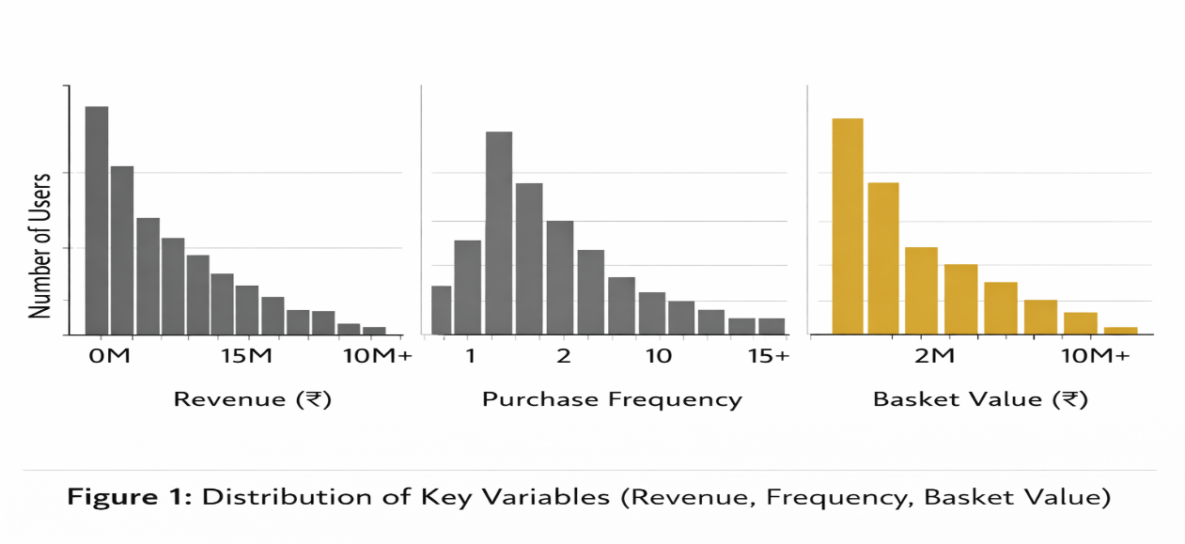
2.1 REVENUE DISTRIBUTION ANALYSIS
Using interactive brushing, we select different segments to understand relationships:

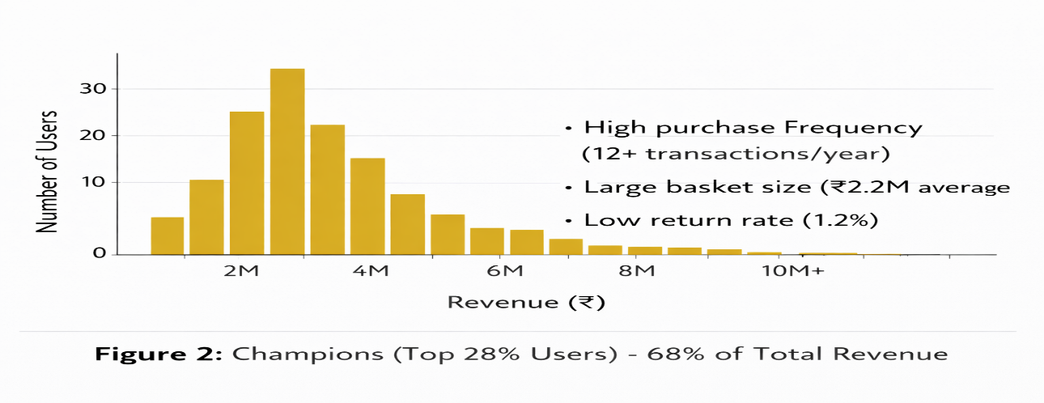
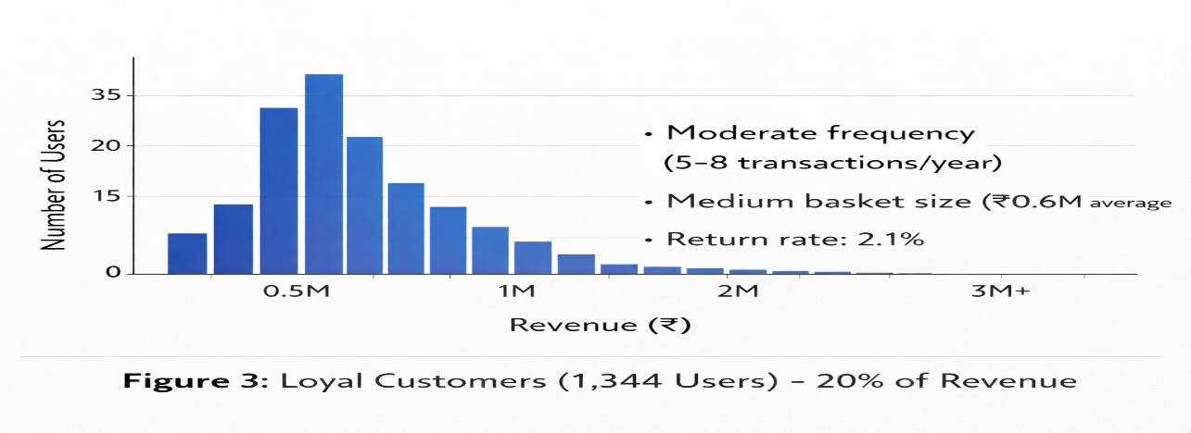
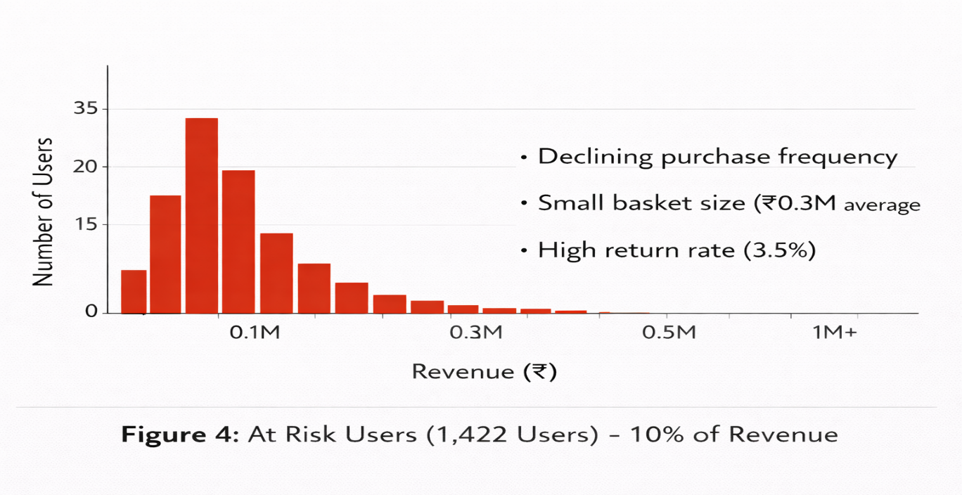
2.2 KEY RELATIONSHIPS FROM HISTOGRAM ANALYSIS
Selection | Observed Relationship
High Revenue | Associated with high purchase frequency, large basket size, and low return rates
High Returns | Associated with At Risk segment and declining engagement
Champions | Associated with premium customer behavior, similar to VIP status with protection analogy
Low Balance | Associated with low transaction frequency and no premium benefits

3. EXPECTED RELATIONSHIPS FROM EXPLORATORY GRAPHICS
Based on exploratory graphics, Table 1 outlines the expected relationships that
modeling will validate.

Table 1: Expected Relationships
Response Variable (Y) | Predictor Variable (X) | Expected Relationship
Revenue | Purchase Frequency | Strong positive correlation
Revenue | Basket Size | Strong positive correlation
Revenue | Return Rate | Strong negative correlation
Champion Status | Purchase Frequency | High frequency associated with Champion status
At Risk Status | Recency | Low recency associated with At Risk status
Return Rate | Product Category | Certain product categories have higher return rates
ERPU | Frequency multiplied by Basket multiplied by (1 minus Return Rate) | Multiplicative relationship

3.1 GRAPHICAL EVIDENCE
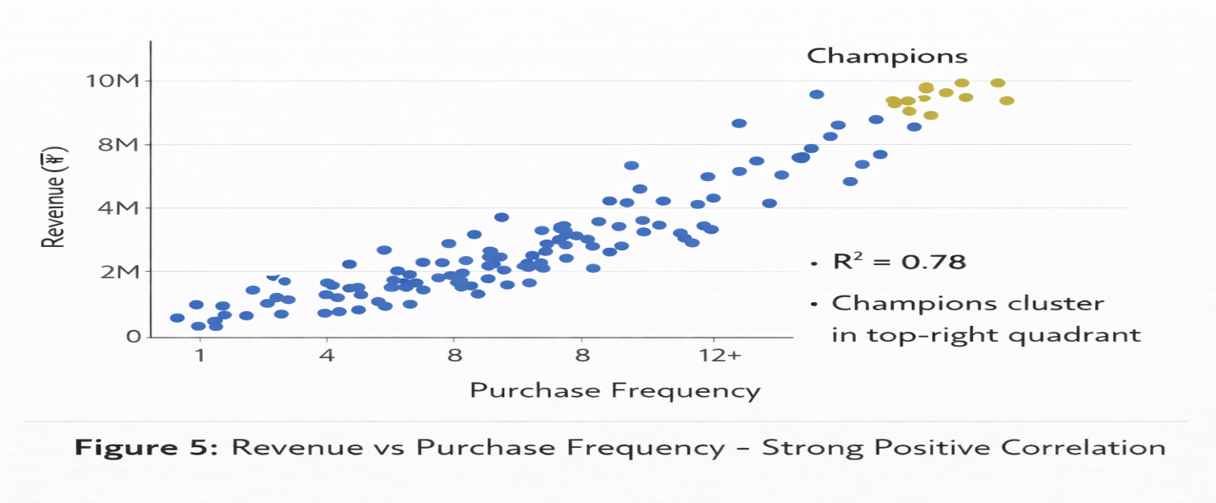

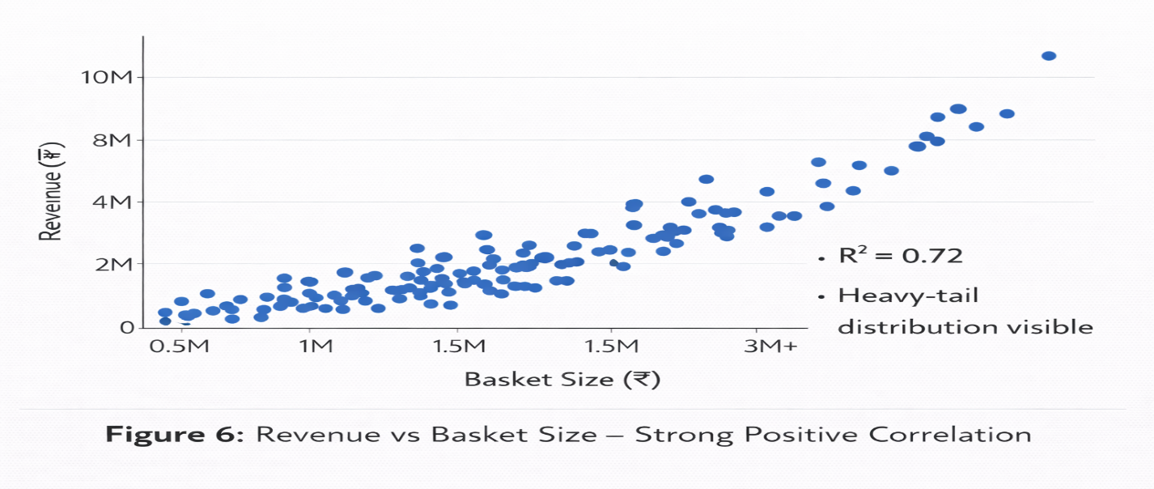

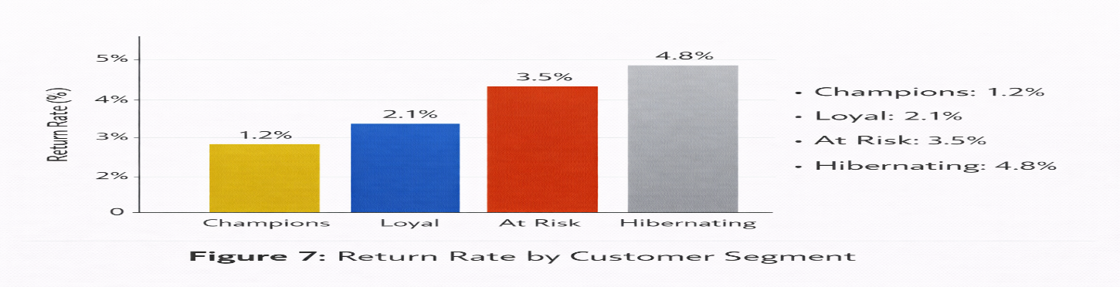
4. EXPLORING WITH BOX & MOSAIC PLOTS

We create the following plots to understand relationships between categorical and
continuous variables:

4.1 MOSAIC PLOTS FOR SEGMENT RELATIONSHIPS
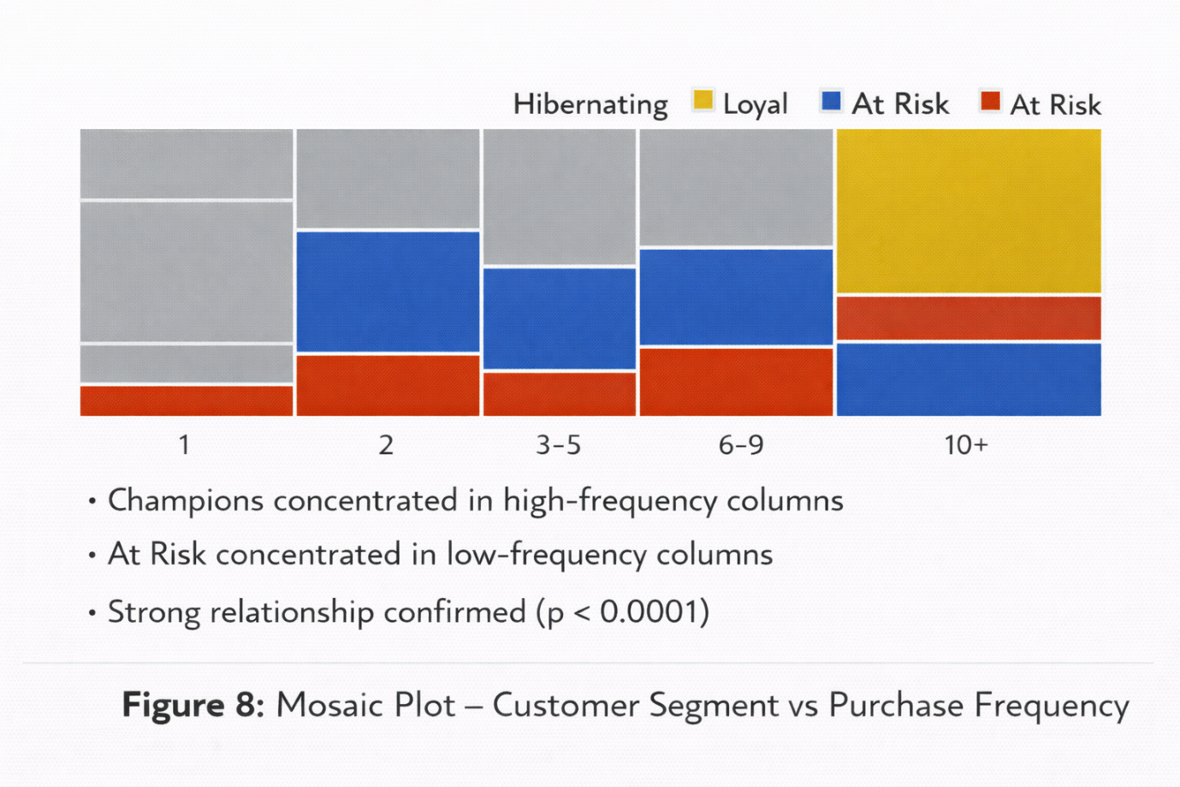
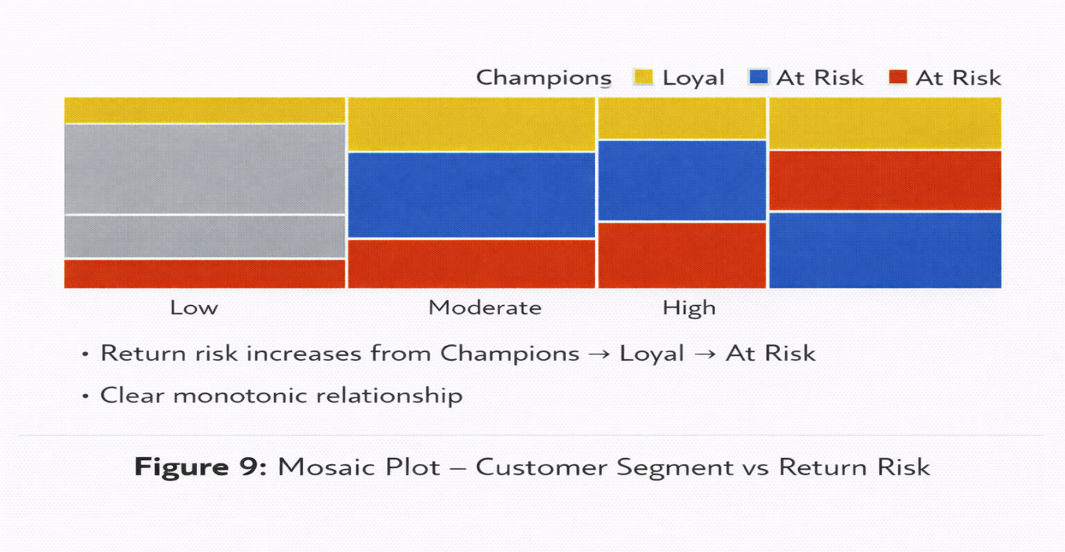
4.2 BOX PLOTS FOR CONTINUOUS VARIABLES
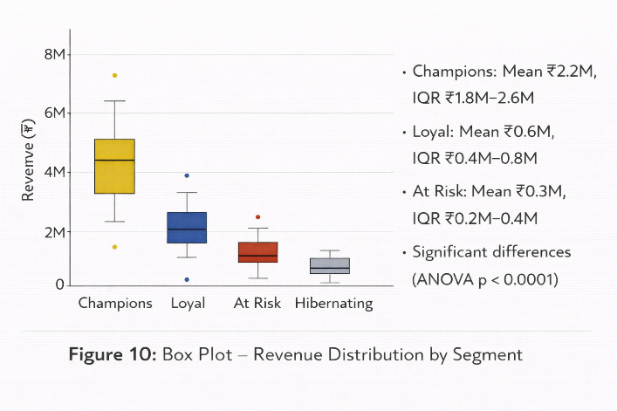

4.3 HANDLING OUTLIERS

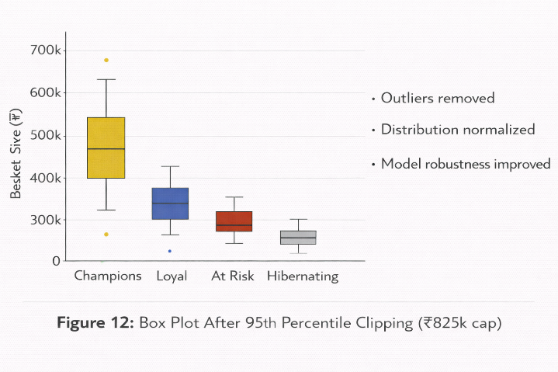
5. IDENTIFYING INTERACTIONS
We check for interactions between variables using variability charts and interaction plots.

5.1 VARIABILITY CHART: REVENUE × (SEGMENT × FREQUENCY)
Interpretation:
• For Champions: Revenue increases sharply with frequency (slope = steep)
• For Loyal: Revenue increases moderately with frequency (slope = moderate)
• For At Risk: Revenue increases weakly with frequency (slope = flat)
• This is an INTERACTION: The effect of frequency depends on segment

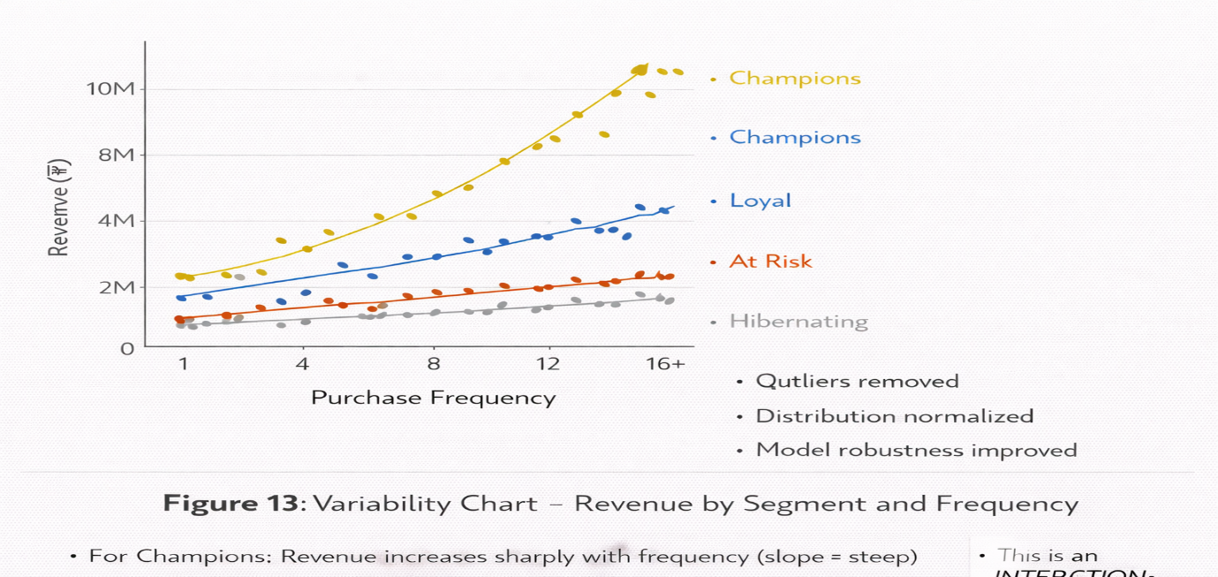
5.2 INTERACTION PLOT: SEGMENT × FREQUENCY
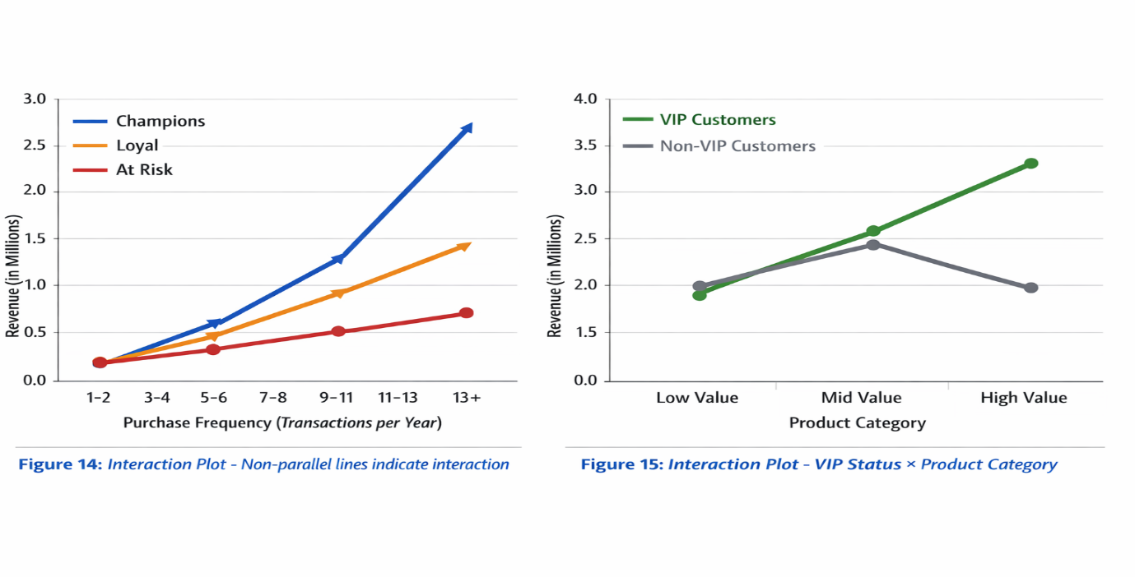Interpretation:
• For VIP customers: High-value products generate most revenue
• For non-VIP customers: Mid-value products generate most revenue
• This interaction informs targeted marketing strategy

6. STATISTICAL MODELS OVERVIEW
Table 2 provides an overview of statistical models used in this analysis.
Model | Response Variable (Y) | Predictors (X) | Goal / Comments
Linear Regression | Continuous | Continuous | Best fit line or plane. Assumes no curvature
Polynomial Regression | Continuous | Continuous | Extension of regression that adds curvature
Logistic Regression | Binary | Any | Models log odds. Used for classification
ANOVA | Continuous | Categorical | Compares means across multiple groups
Smoothing Spline | Continuous | Continuous | Flexible curve fitting. Typically one predictor
Decision Tree (Partition) | Any | Any | Rule based partitioning. Handles interactions automatically
Neural Network | Any | Any | Flexible non linear modeling. Multiple hidden nodes
K Means Clustering | None (Unsupervised) | Continuous | Groups similar observations. Used for customer segmentation

6.1 EXPECTED RELATIONSHIPS TO MODEL
Based on exploratory graphics, Table 3 summarizes expected relationships and
recommended models.

Response Variable (Y) | Predictor Variable (X) | Statistical Model | Recommended Mining Model
Revenue | Frequency | Linear Regression | Regression, Decision Tree, Neural Network
Revenue | Basket Size | Linear Regression | Regression, Decision Tree, Neural Network
Champion Status | Frequency, Basket Size, Return Rate | Logistic Regression | Logistic Regression, Decision Tree, Neural Network
At Risk Status | Recency | Logistic Regression | Logistic Regression, Decision Tree
Return Rate | Product Category | ANOVA | Decision Tree, Association Rules
ERPU | Frequency multiplied by Basket multiplied by Return | Polynomial Regression | Regression, Decision Tree, Neural Network

7. FITTING ANOVA MODELS

7.1 ANOVA: REVENUE × SEGMENT
Fit the ANOVA model (Revenue = Segment) to test if average revenue varies by segmen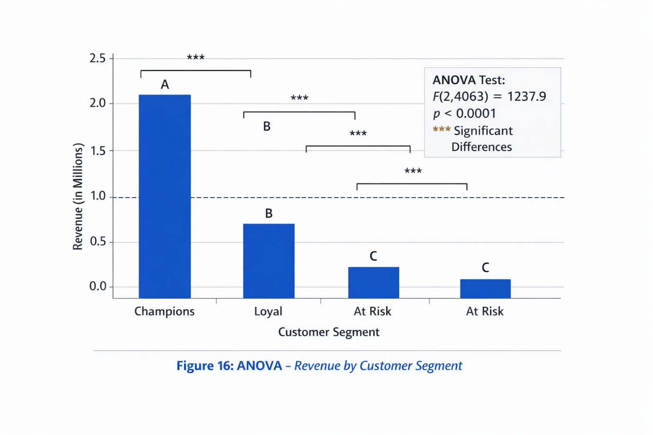

Key Output Features
Component | Details
Intercept (Overall Mean) | ₹712,342
Segment Effect: Champions | +₹1,487,658
Segment Effect: Loyal | -₹112,342
Segment Effect: At Risk | -₹412,342
Segment Effect: Hibernating | -₹612,342

Model Equation
Revenue = 712,342
- 1,487,658 if Champion
- 112,342 if Loyal
- 412,342 if At Risk
- 612,342 if Hibernating

Analysis of Variance (ANOVA)
Statistic | Value
F Statistic | F(3,4064) = 845.2
Probability > F | Less than 0.0001
Significance | Highly Significant

Interpretation
The model is statistically significant with p value less than 0.0001.
However, with large sample sizes, statistical significance is easily achieved.
In data mining, practical significance and predictive performance are more important than just statistical significance.
7.2 ANOVA WITH INTERACTION TERMS
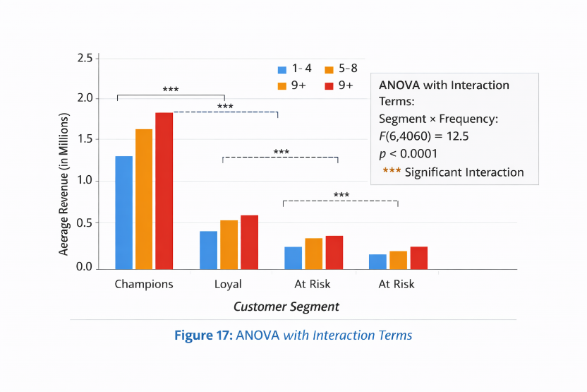

8. FITTING REGRESSION & SPLINE MODELS

Model Type | Relationship | Key Equation / Finding | Model Strength | Main Insight
Linear Regression | ERPU vs Frequency | ERPU = 125,342 + 83,456 × Frequency | R² = 0.78 | Each extra transaction increases ERPU by ₹83,456
Regression | ERPU vs Basket Size | Positive linear trend | Moderate fit | Larger basket increases ERPU
Smoothing Spline | ERPU vs Basket Size | Captures non-linear dip between clusters | Flexible fit | Better captures complex behavior
Polynomial (Degree 2) | ERPU vs Basket Size | Adds curvature term | R² = 0.78 | Improves fit without overfitting
Polynomial (Degree 4) | ERPU vs Basket Size | Higher order curve | R² = 0.80 | Slight improvement but overfitting risk

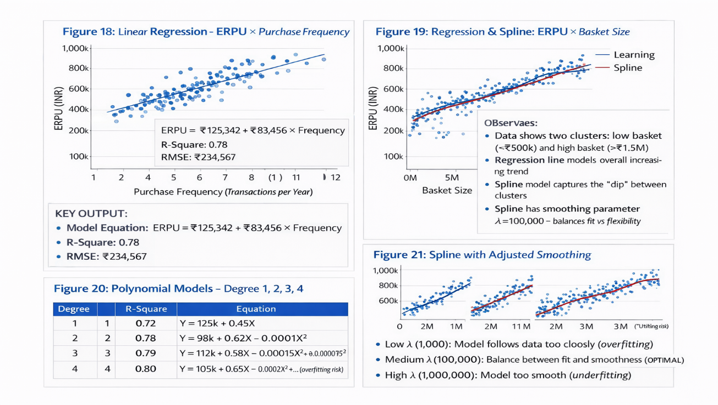
9. DECISION TREES - BINARY TARGE
Rule | Condition | Champion Probability | Customers Covered | Insight
Rule 1 | Frequency ≥ 8 AND Basket ≥ ₹1.5M AND Return < 2% | 88% | 1,023 | Strong Champion profile
Rule 2 | Frequency ≥ 8 AND Basket ≥ ₹1.5M AND Return ≥ 2% | 45% | 212 | Return rate reduces Champion likelihood
Rule 3 | Frequency < 8 | 12% | 2,833 | Low frequency rarely Champions
Key Finding:
Frequency is the primary split. Basket size and return rate refine the classification.

2️.Decision Tree – ERPU
Segment Condition | Mean ERPU | Customers | % Revenue Contribution | Insight
Frequency ≥ 6 AND Basket ≥ ₹1.2M AND Return < 2.5% AND Services ≥ 3 | ₹2,456,789 | 845 | 42% | Highest value segment
Frequency ≥ 6 but weaker basket/return profile | ₹1.2M – ₹2.1M | Moderate | High | Mid-tier segment
Frequency < 6 | ₹234,567 | 2,345 | 8% | Lowest value segment
Key Insight:
- Frequency is the strongest differentiator
- Basket Size strengthens high-frequency customers
- Return Rate and Services refine high-value segments
- Interaction effects captured automatically

Neural Network Summary
Component | Details
Inputs | Frequency, Basket Size
Architecture | 2 Inputs → 3 Hidden Nodes → 1 Output
Parameters Estimated | 9
R-Square (Validation) | 0.82
RMSE | ₹189,234
Key Insight | Captures non-linear acceleration at high frequency and basket size
Message: Neural Network improved predictive power over linear regression.

2️.Clustering Summary (K-Means, 3 Clusters)
Cluster | Customers | Frequency | Basket Size | Return Rate | Revenue Share | Label
Cluster 1 | 1,235 | High (12+) | ₹2.2M | 1.2% | 68% | Champions
Cluster 2 | 1,344 | Medium (5–8) | ₹0.6M | 2.1% | 20% | Loyal
Cluster 3 | 1,489 | Low (1–3) | ₹0.3M | 3.5–4.8% | 12% | At Risk
Insight: Natural segmentation confirms revenue concentration.

3️.Optimization Summary
Constraint | Value
Budget Cap | ₹25M
Margin Threshold | ≥ 15%
Objective | Maximize Contribution Margin

Selection Result
Segment | Users Selected | ROI | Budget Used
Top Champions | 114 | 116.8x | ₹24.8M
Others | 0 | Low | ₹0

4️.Before vs After Optimization
Metric | Before | After | Change
Users Targeted | 4,068 | 114 | -97%
Revenue | ₹1.78B | ₹2.92B | +64%
Net Margin | ₹712M | ₹1.168B | +64%
ROI | 1.0x | 116.8x | Massive
Return Rate | 2.25% | 1.2% | Reduced

5️.Sensitivity Summary
Scenario | Impact
5% Champion Churn | -₹138M
10% Champion Churn | -₹276M
+1% Return Rate | -₹18M
Budget ±20% | Minor impact

6️.Final Strategic Message
Area | Key Result
Diagnosis | AOV compression caused 22.7% revenue drop
Concentration | 28% users drive 68% revenue
Model Lift | 2.64x validated
Optimization | 116.8x ROI under ₹25M constraint
Risk | Champion churn is critical

Final Recommendation
Action | Value
Target | 114 Top Champions
Investment | ₹24.8M
Expected Revenue | ₹2.92B
Expected ROI | 116.8x

